**DAY-6 OUTPUT:**

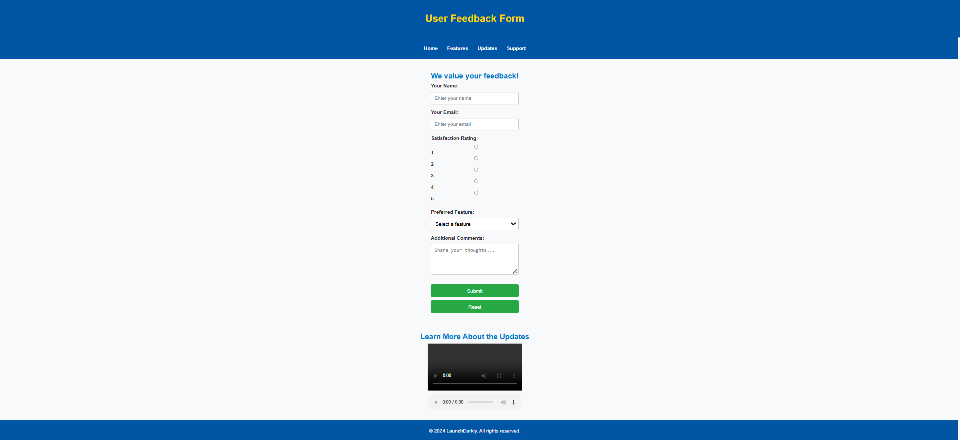

**MESSAGE POP UP FOR SUBMITTING THE FEEDBACK:**

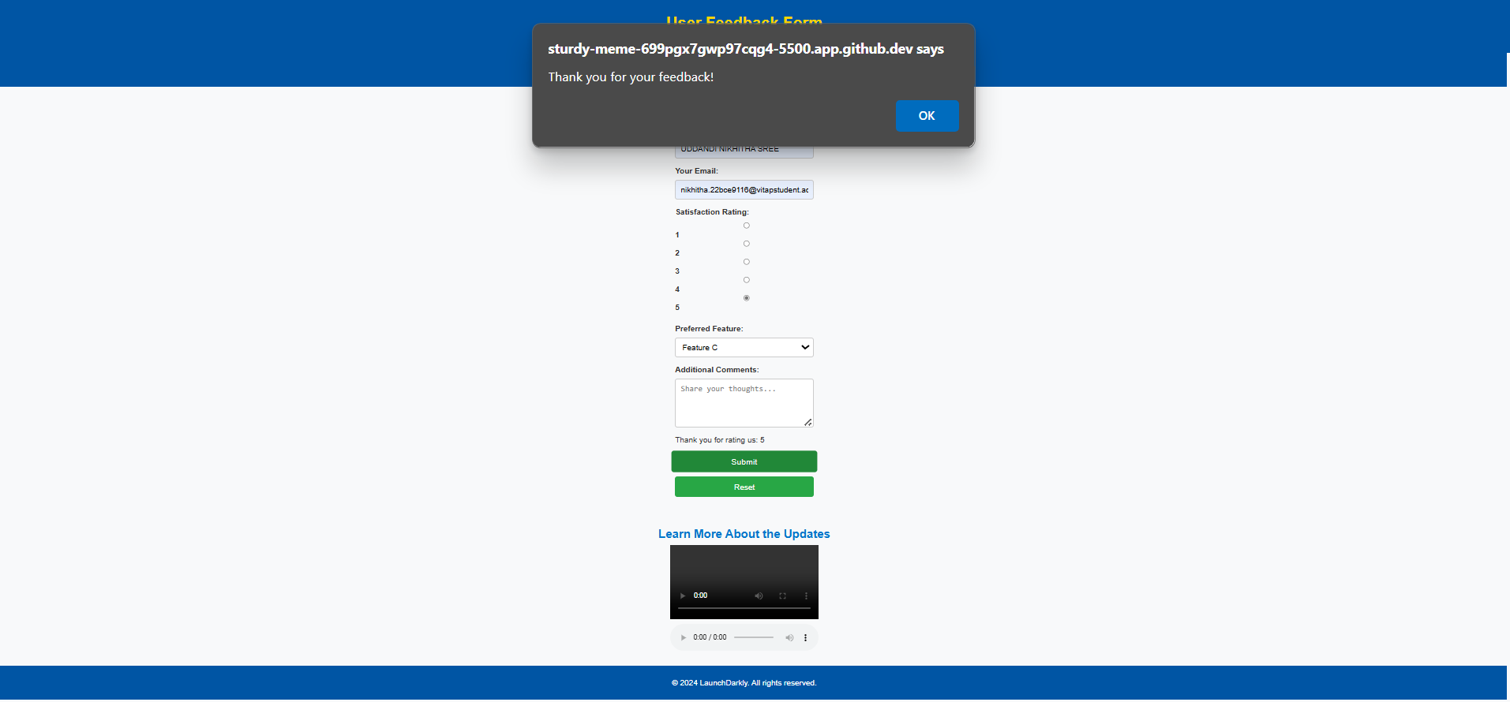

**MESSAGE POP UP IF SATISFACTION LEVEL NOT SELECTED:**

